Shelby Pace, Kaleigh Key, Nathan Cooley, Christopher Hebert, Brad Ewing, and Michael Towns

Dr. Kevin Cherry

CSC 490B

3 January 2018

Second Requirements Draft

**Functional Requirements:**

***Basic Search***

|  |  |
| --- | --- |
| **FR1:** | The user shall be able to search by scientific or common name. |
| **FR2:** | A user search shall produce a selectable list of species names, with the common name preceding the scientific name. |
| **FR3:** | The selectable list should display a preview image of the species next to its name. |
| **FR4:** | The application will have a “What’s Around Me?” button on the home screen which will populate a list of the species within a mile radius specified by the user (defaulting to 10 miles). |
| **FR5:** | The application shall keep a record of past searches made by the user. |
| **FR6:** | The user shall be able to specify the type of search he or she is making (common name, scientific name, state, or state with county/parish/organized borough). |

***Filter***

|  |  |
| --- | --- |
| **FR7:** | The application shall filter search results using the user’s GPS, showing the species within a range specified by the user (defaulting to 50 miles). |
| **FR8:** | The application shall populate a list of the species within a state which is selected or searched for by the user. |
| **FR9:** | The application shall allow the user to obtain a list of the species within a selected or searched for county, parish, or organized borough name. |
| **FR10:** | A user shall be able to filter search results by selecting a taxonomic rank. This includes kingdom, phylum, class, order, family, genus, species.**Table 1:** This table shows the taxonomic classification levels that the user would be able to search from, with example usage under ‘Examples.’ |
| **FR11:** | The user shall be able to filter his or her search for species by inputting a specific event date. |
| **FR12:** | The user shall be able to select multiple filters to widen or narrow his or her search. |

***Species Page***

|  |  |
| --- | --- |
| **FR14:** | When selecting the preview image or the species name, the user shall be directed to a page containing additional information about the species. |
| **FR15:** | The species page should have a link to a page (possibly EOL or Wikipedia) which will provide more information about the species. |
| **FR16:** | The species page shall include a citation which gives credit to the data provider.   |  |  | | --- | --- | | **Citation Information** | **Example or Required Inputs** | | Data Provider or Owner Name | Field Museum of Natural History or Gordon, J. | | Resource or Dataset Name | U.S. Bird Occurrences | | Publisher [Data Provider name, address or affiliation(s)] | Field Museum of Natural History, Museum of Vertebrate Zoology, University of Washington Burke Museum, and University of Turku | | Service Used to Access | *Biodiversity Information Serving Our Nation (BISON)* | | URL | *https://bison.usgs.gov* | | Date | YYYY-MM-DD | |

***Personal Recordings***

|  |  |
| --- | --- |
| **FR17:** | The user shall have the ability to access his or her camera within the app to take and save photos of observed organisms. |
| **FR18:** | The user shall be able to take and save audio recordings of observed organisms. |
| **FR19:** | The user shall be able to group saved images and audio recordings under a specific name. |
| **FR20:** | The application shall allow the user to add a location to their photo and/or audio recording. The user can select a specific location or use their current GPS location. |

***Downloading***

|  |  |
| --- | --- |
| **FR21:** | The application should offer a way to download data from a set location for offline use. |

***Settings***

|  |  |
| --- | --- |
| **FR22:** | The user shall be able to access the settings menu through a button in the top right hand corner of the screen. |
| **FR23:** | The settings menu shall contain a toggle to enable/disable preview images, showing only the species names. |
| **FR24:** | The settings shall allow the user to clear his or her search history. |
| **FR25:** | The settings shall allow the user to clear the cache of downloaded data. |
| **FR26:** | The user shall be able to change the distance that the “What’s Around Me?” button searches within the settings.   |  |  |  | | --- | --- | --- | | **Toggle for Images** | Enabled | When the toggle switch is enabled, a user’s search will generate images of the organisms returned from the search. | | Disabled | When the toggle switch is disabled, a user’s search will not generate images of the organisms returned from the search. This will decrease load times if the user has poor cellular connection. | | **Clear Searches** | This will be a clear history button that will clear the user’s search history when pressed. | | | **Clear Downloaded Data** | This will be a clear cache button that will clear all downloaded data from the user’s cache when pressed. | | | **Mile Radius Selection** | This will be a drop-down bar that allows the user to select a 5, 10, 25, 50, or 100 mile radius. | |   **Table 3:** Above is a table that describes how each of the settings in **FR21 - FR24** will be handled in the settings menu of the application. |

***Map***

|  |  |
| --- | --- |
| **FR27:** | The user should be able to do a map search for a species which shows the locations where the species was observed. |
| **FR28:** | The user should be able to click the observation on the map and be directed to a page with additional information about the species/observation. |

***Basic Features***

|  |  |
| --- | --- |
| **FR29:** | The application shall have a banner that directs the user back to the home screen. |
| **FR30:** | The application shall have a help page providing a short tutorial detailing the functions of the application which will be accessible through a button in the top left hand corner of the screen. |
| **FR31:** | The application shall utilize multiple APIs to acquire information about species, such as name, location, data provider, etc.   |  |  | | --- | --- | | **APIs** | **Usage** | | Biodiversity Information Serving Our Nation (BISON) | The BISON API can retrieve a list of occurrences for a given species by searching using the selected state and county or entering latitude and longitude. | | Encyclopedia of Life (EOL) | The EOL API can search for a specific species and obtain information such as physical descriptions, habitat, images, and a map of known areas in which the species lives. | | Global Biodiversity Information Facility (GBIF) | The GBIF API can search for a species using its scientific and common name, habitat, family, etc.  The GBIF API allows for the ability to create and edit information in their data system. Additionally, this API can search occurrence records in the GBIF archive, and it offers a mapping service. |   **Table 4:** The above table shows the APIs that will be used and how they will be implemented |
| **FR32:** | The application shall have a back button on each page, allowing the user to return to the previous page. |

***Image Recognition***

|  |  |
| --- | --- |
| **FR33:** | The application should be able to perform image recognition when the user inputs an image of an species. |

**Nonfunctional Requirements:**

|  |  |
| --- | --- |
| **NFR1:** | An untrained user should be able to intuitively navigate the simple search method to find information about a species. |
| **NFR2:** | This application shall translate on all screen sizes so that a user with any type of Android phone can view the application properly. |
| **NFR3:** | The application shall be able to function without significant loading times using only a limited cell connection (3G, minimum). |

**Initial Prototype:**

Below is the initial prototype for the Flora application. It includes the home screen of the application that uses buttons to direct the user to the features of the application. The general search would be used if the user wanted to perform a simple search such as searching for spiders in their area. The advanced search would be used if the user wanted to search for organisms using their taxonomy information such as kingdom, phylum, class, order, family, genus, and species.

It also includes a search bar that the user would use to search for species in a given location. The category drop-down bar would represent the kingdom of the organism and the type drop-down bar would represent the family of the organism. The user could select a date to view organisms that are in the given location at the chosen date.

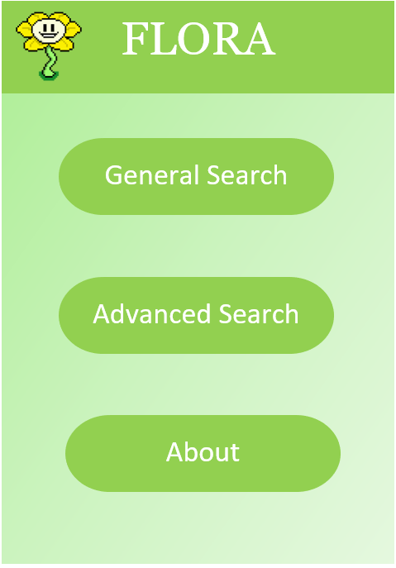

**Second Prototype:**

For the second prototype, some additional features were added based on customer feedback. The way searches were performed was changed, and the user interface was modified.

Below is the modified home screen. 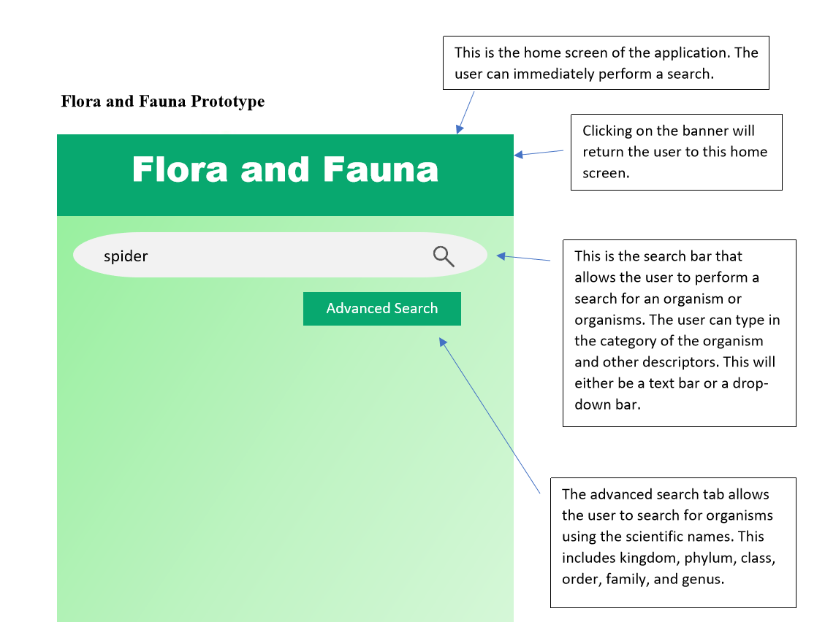

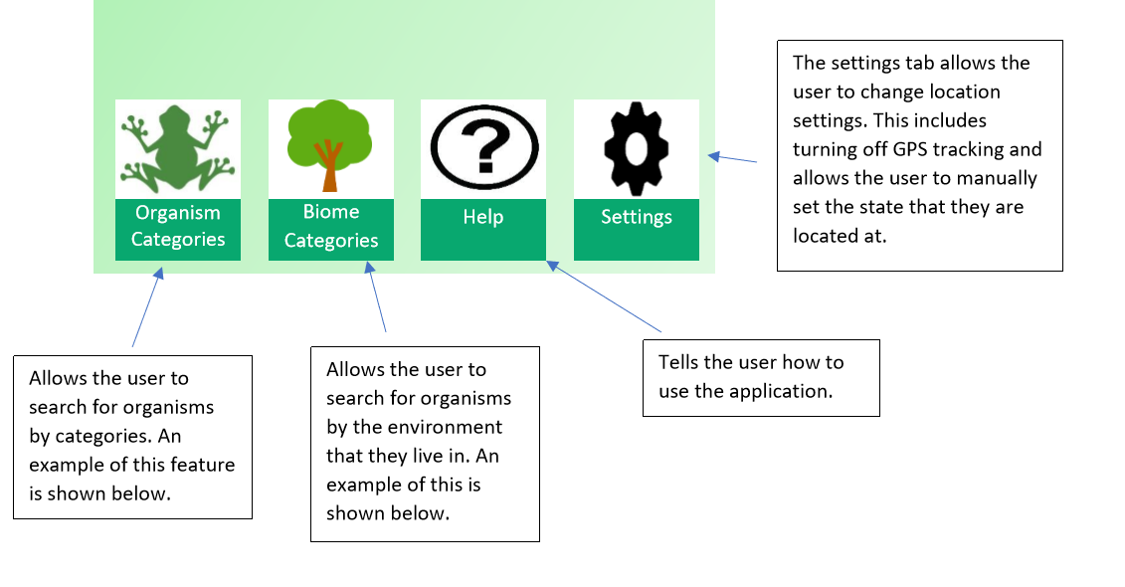

Below is an example of a user’s search.

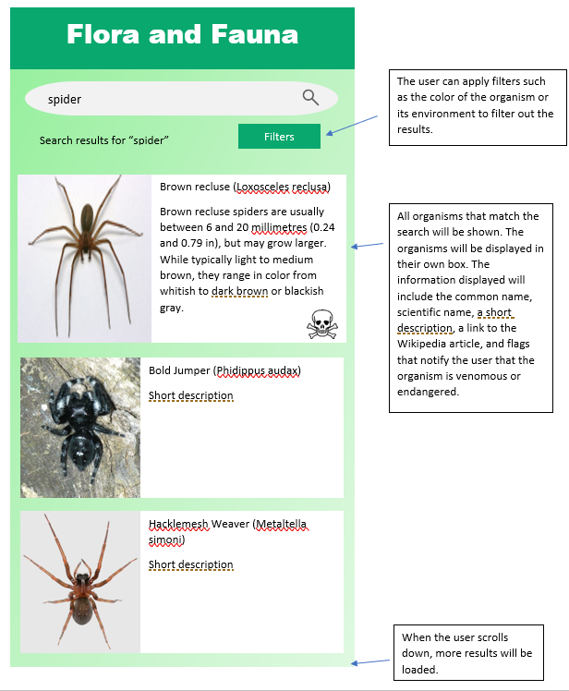

Below is an example of the user using the Organism Categories feature to search for organisms.

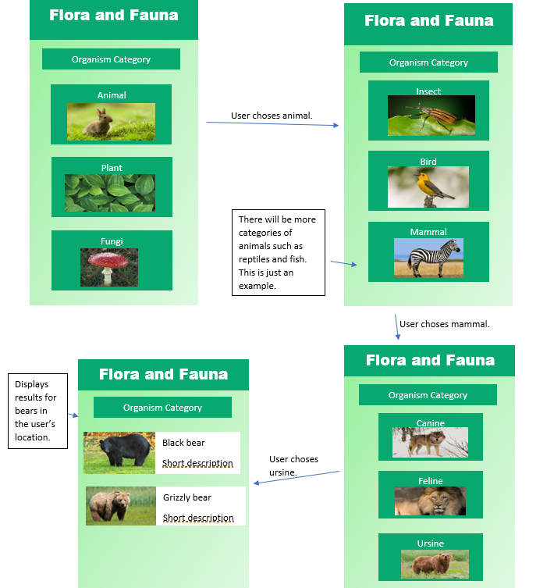

Below is an example of the user using the Biome Categories feature to search for organisms. 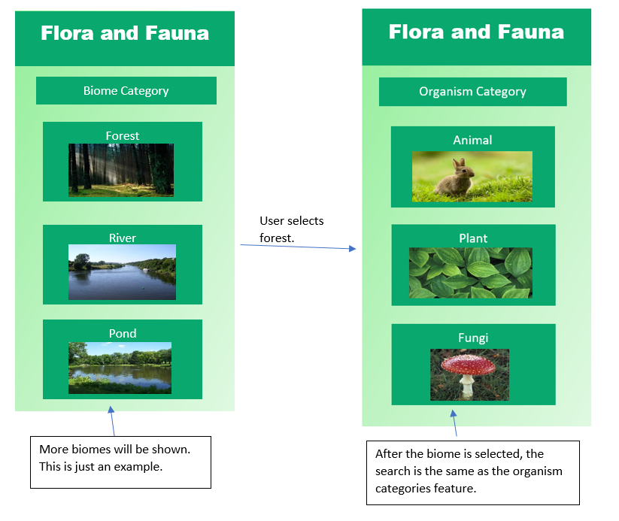

**Prototype Objectives:**

1. Determine how the filters/categories would function
2. Figure out format of the home screen with the search box and other options
3. Decide on the appearance of the user interface
4. Receive feedback from clients on the usability of the user interface

**Prototype Feedback:**

1. Todd Buffington - We sent Todd the initial prototype, and he gave us the following feedback:

“One thing that hit me right off is to eliminate choices by habitat type. A bottomland-hardwood habitat would have different species than upland-pine. It could also be broken down by aquatic or terrestrial. There may be some way to utilize the GPS function of a smartphone to establish habitat type using existing GIS data.”

This feedback urged us to look into the development of filters. We are still looking into how to make a filter for habitats; however, we have not been able to find data that is specific to habitat. We are working on figuring out how to coordinate GIS data with the observation data from the APIs we currently plan to use. We have sent Todd the second prototype, but he has not replied yet.

1. Dr. Box Leangsuksun - Dr. Box responded to our initial prototype by urging us to look into existing applications. He spoke with us about adding where a user can upload their own pictures and audio recordings. Additionally, he suggested we look into image recognition, but he warned that it may not be incredibly accurate.

After showing Dr. Box the second prototype,0Other users can then see these user recorded observations. He also recommended that the user could upload an image and audio recording of the species to go along with the observation. Dr. Box also recommended that the application have a feature where the user can download data from a set location for offline use since most users would be in locations with limited or no cellular service.

**Requirements Affected:**

1. FR2
2. FR3
3. FR8
4. FR10
5. FR11
6. FR15
7. FR16
8. FR20
9. FR27
10. FR28
11. FR30
12. FR31
13. NFR1